ML project documentation

Dataset details:

Numerical
- Name: insurance.csv
- Number of classes: 7
- Number of samples in dataset: 1,338
- Number of samples used for training: 1,070
- Number of samples used for testing: 268

Image
- Name: Malaria Cell Images Dataset
- Number of classes: 2, parasitized and uninfected
- Number of samples in dataset: 10,000 samples
- Size of samples in dataset: 96 x 96 pixels, greyscale
- Number of samples used for training: 7,000
- Number of samples used for validation: 1,500
- Number of samples used for testing: 1,500

Implementation details:

Feature extraction phase
- Number of features extracted: 14
- Names of features extracted:
For image:
HOG, LBP, GLCM: contrast, dissimilarity, energy, ASM
Statistical features: mean, std, range, skewness, kurtosis
For numerical data:
Sex, smoker and region
- Dimension of extracted features:
For image:
HOG: orientations=9, pixels_per_cell=(8,8), cells_per_block=(3,3)
LBP: (P=8, R=1) and (P=16, R=2)
Mean = 0
Std = 1
Final feature vector reduced to 50 dimensions using Incremental PCA.
For numerical data:
Sex: 1 dimension
Smoker: 1 dimension
Region: 3 dimensions

Cross-validation
No cross validation used
Hyperparameters
- Epochs: 100
- Intial learning rate: adaptive, no intial rate
- Silhouette Score: 0.068
- Batch size: 19,290
- Optimizer: SAGA
- Regularization: L1, L2
- PCA Components: 800
- Max iterations: 2,000

Result details:

Numerical
- Loss curve:
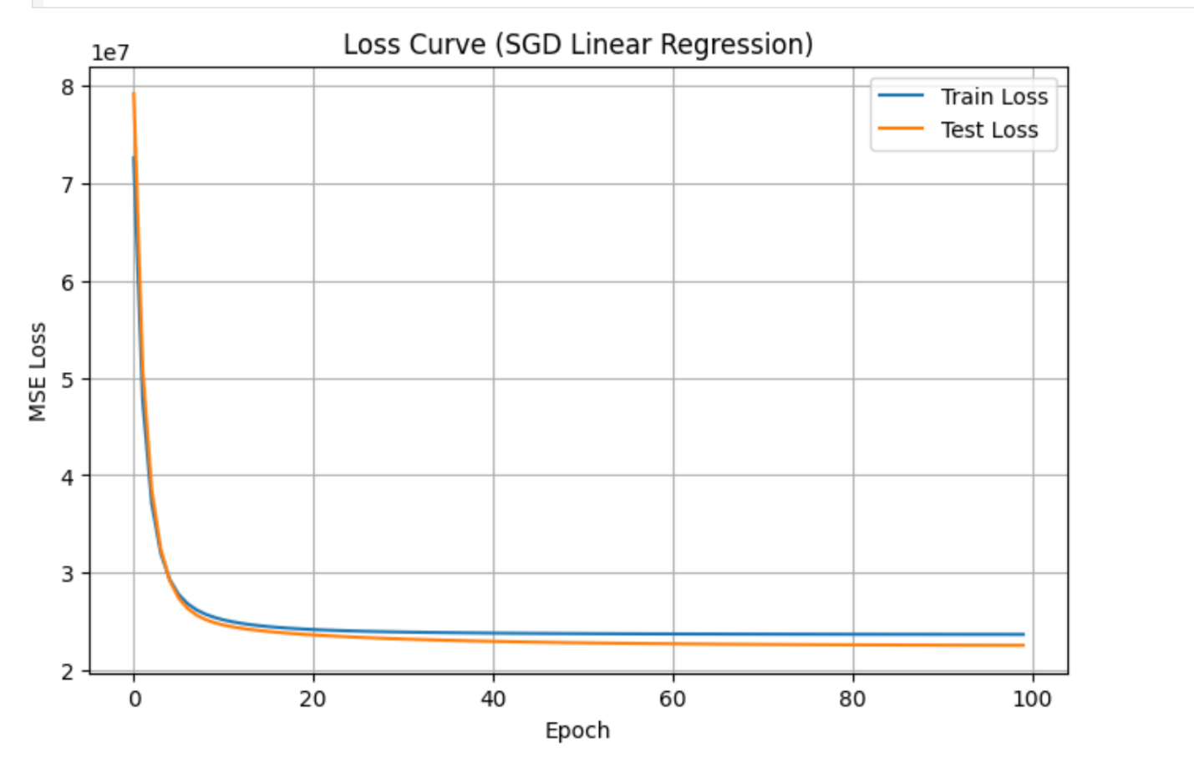
- Accuracy:
70%

- Confusion matrix: not applicable
- ROC curve: not applicable

Image
- Loss curve:
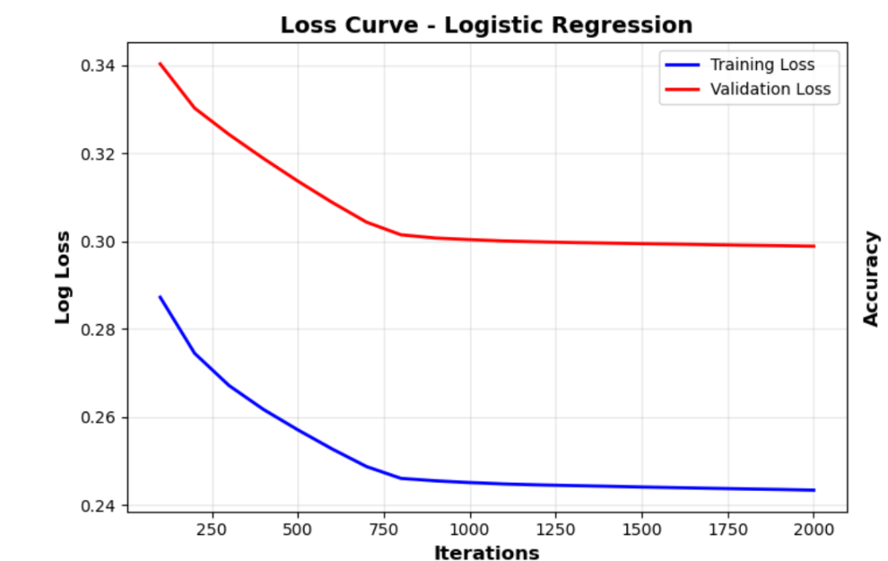
Final Training Log Loss: 0.2434
Final Validation Log Loss: 0.2989

- Accuracy:
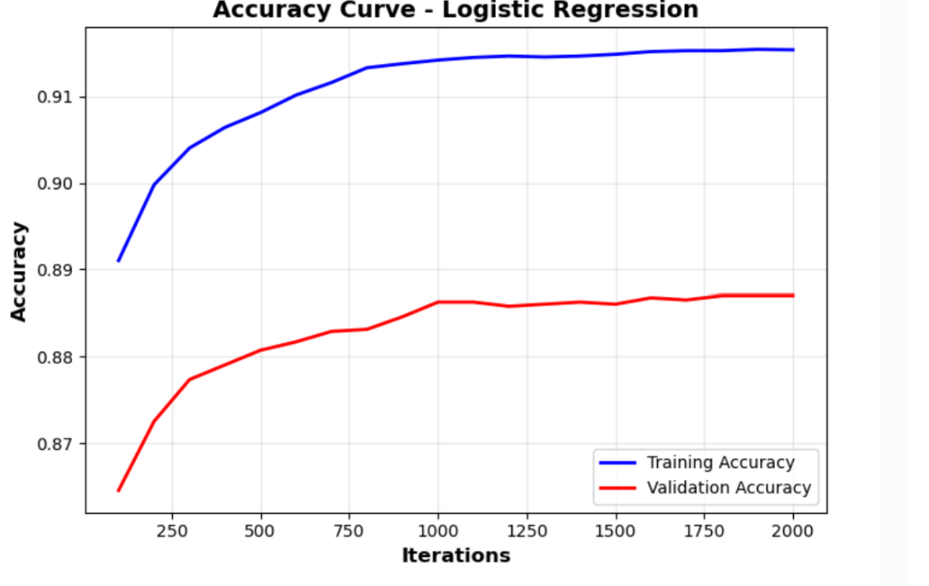
Final Training Accuracy: 0.9154
Final Validation Accuracy: 0.887
Test Accuracy: 0.8924

- Confusion matrix:
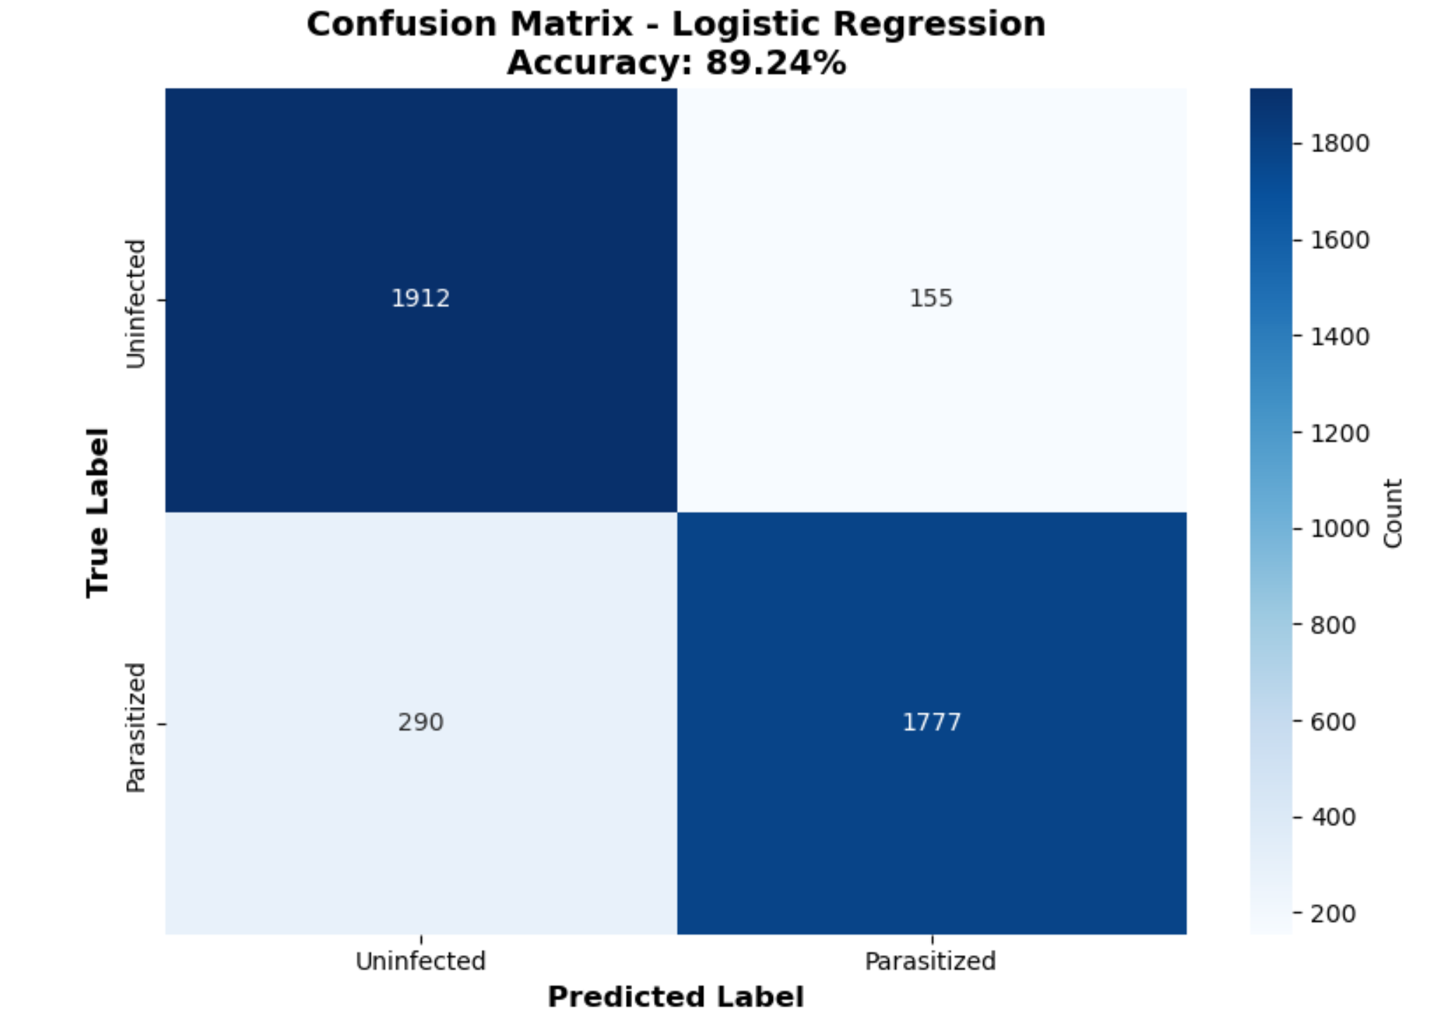
Detailed Metrics:
Sensitivity (Recall): 85.97%
Specificity: 92.50%
Precision: 91.98%

K-means:

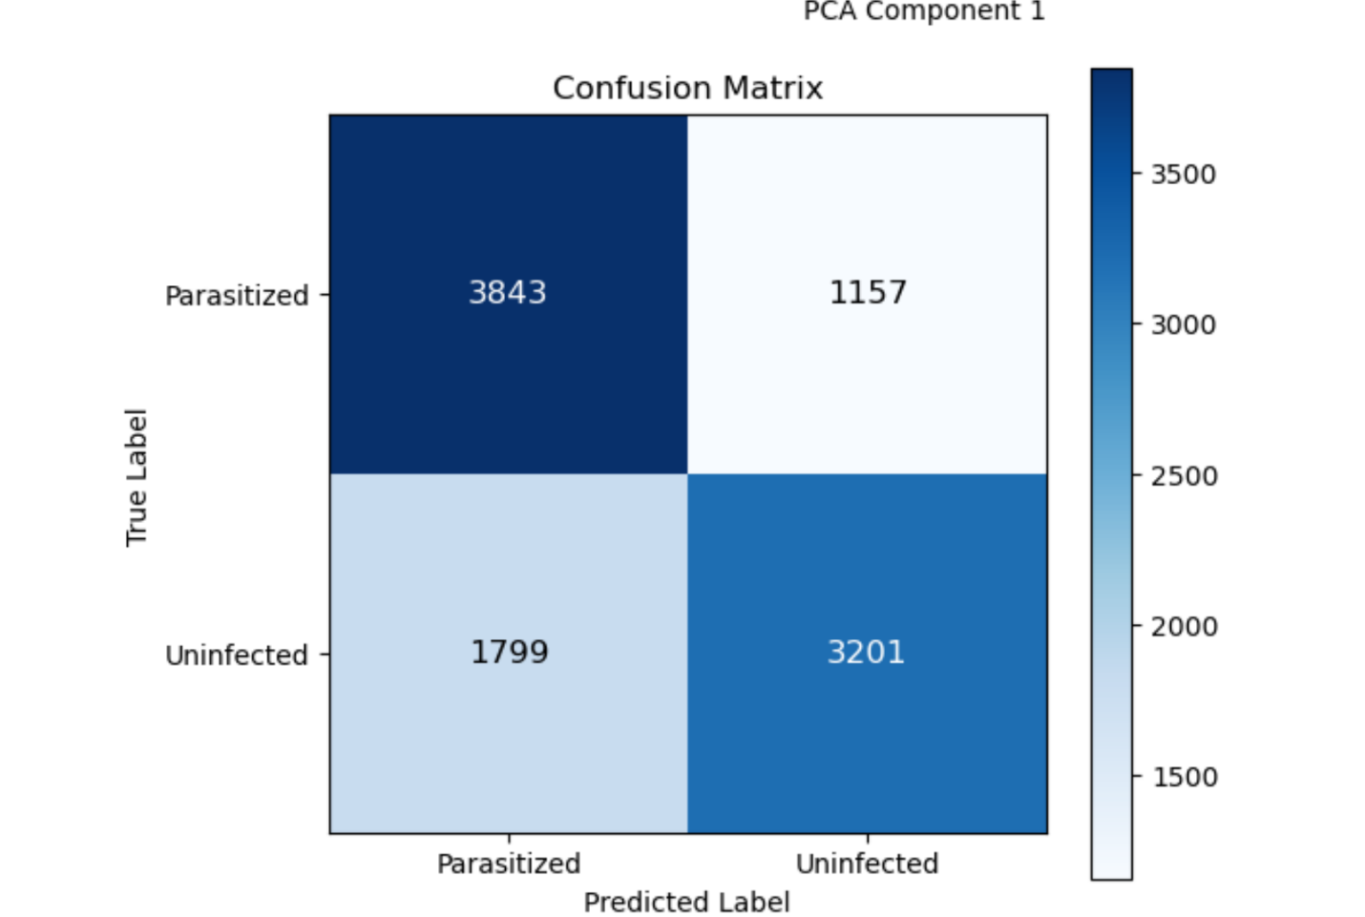

- ROC curve:
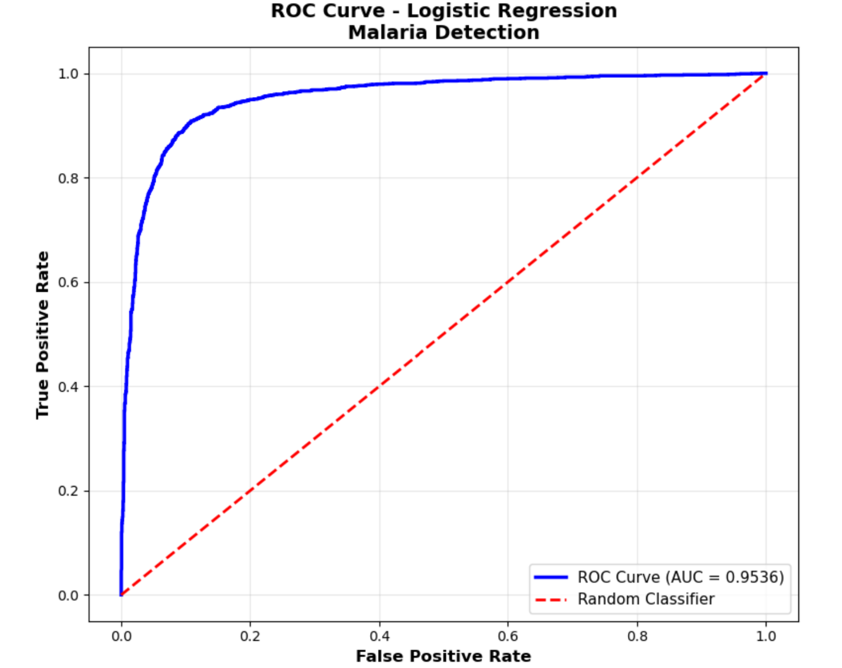

K-means:

